COPY

Client: AWA

Project: Fantasia

Optimiser: John Barnes

Copywriter: Mel Henson

Date: 16 June 2015

Ref: AWA/ MH/V1

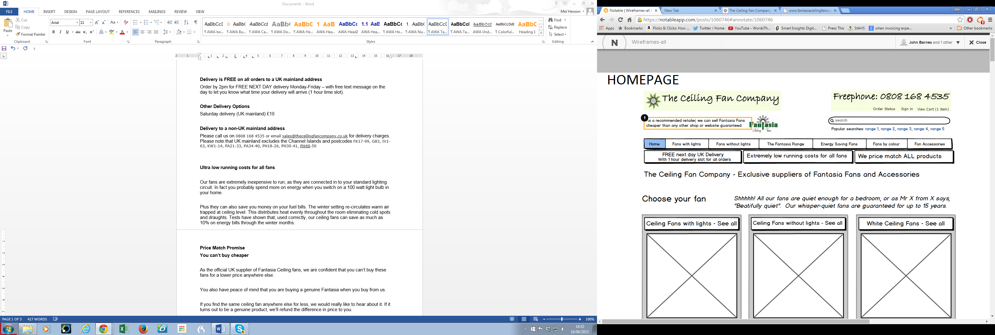

Why Choose Fantasia Ceiling Fans?

* *See below for text*

**Why Choose Fantasia Ceiling Fans?**

|  |  |
| --- | --- |
| * BUILT TO LAST – 10 year warranty * ULTRA QUIET – the most silent on the market * SAVE ENERGY – cut 10% off winter fuel bills | * REMOTE CONTROL – lots of options * EASY TO INSTALL – uses existing light circuit * GREAT CHOICE – huge range of colours and sizes |



**FREE Next Day UK Delivery**

**with 1 hour delivery slot**

**Delivery is FREE on all orders to a UK mainland address**

Order by 2pm for FREE NEXT DAY delivery Monday-Friday – with free text message on the day to let you know what time your delivery will arrive (1 hour time slot).

**Other Delivery Options**

Saturday delivery (UK mainland) £18

**Delivery to a non-UK mainland address**

Please call us on 0808 168 4535 or email [sales@theceilingfancompany.co.uk](mailto:sales@theceilingfancompany.co.uk) for delivery charges. Please note that UK mainland excludes the Channel Islands and postcodes FK17-99, G83, IV1-63, KW1-14, PA21-33, PA34-40, PH18-26, PH30-41, PH49-50



**Ultra low running costs for all fans**

Our fans cost very little to run, as they need very little energy, similar to a standard light fitting. In fact you use more on energy when you switch on a 100 watt light bulb.

All our fans have precision engineered, silicon steel motors which are highly efficient to run. Some models come with ultra-low energy LED lights or low energy halogen bulbs and others have a DC motor which uses 60% less power than a standard fan.

What’s more, our ceiling fans can actually save you money on your fuel bills. The winter setting re-circulates warm air trapped at ceiling level, which distributes heat evenly throughout the room eliminating cold spots and draughts. Tests have shown that, used correctly, our ceiling fans give you savings of up to 10% on energy bills through the winter months.



**Price Match Promise**

**You can’t buy cheaper**

As the official UK supplier of Fantasia Ceiling fans, we are confident that you can’t buy Fantasia fans for a lower price anywhere else.

You also have peace of mind that you are buying a genuine Fantasia when you buy from us.

If you find the same ceiling fan anywhere else for less, we would really like to hear about it. If it is a genuine Fantasia ceiling fan (not an inferior imitation), we’ll refund your entire cost.

**Why Fantasia Fans from The Ceiling Fan Company?**

Quite simply, no other fans on the market are better quality or more beautifully designed. We have been official suppliers of Fantasia Fans for over 15 years, so we know a lot about what makes a great ceiling fan. Here’s just some of the reasons why Fantasia Fans are unsurpassed by any others:

✔ 10 year warranty

Our fans are maintenance free and built to last, with all-metal motor housings and double-lacquered surfaces to keep them in pristine condition for many years to come. Each fan comes with a 10 year warranty – longer than any other ceiling fans on the market. If you have any motor problems within ten years of buying your fan, just let us know and we’ll repair or replace it free of charge.

✔Unbeatably quiet

All our ceiling fans are virtually silent because they are precision-engineered with large silicon steel motors, permanently sealed bearings and aerodynamically shaped blades. When the fan is on in your home, the loudest sounds you’ll hear are the birds in your garden and the ticking of your clock.

✔Huge choice

You have a huge range of ceiling fan designs to choose from, some with lights and others without, in styles ranging from contemporary to classic. Many fans are available in a choice of two sizes with several blade options, and you can also change the blade colours within each range.

✔Easy to install and use

Your fan can be installed on a high ceiling, sloping ceiling or low ceiling as well as conservatory buildings – simply purchase the appropriate mounting. The fan runs from your existing light circuit using the same wiring, so it’s very easy to install. Using it is easy too. To switch your fan on and off and control the speed you have a choice of traditional pull cord or a remote control.

✔Great after sales service

Free next day delivery (UK mainland) comes as standard, so your fan will be with you in no time. But our commitment to you doesn’t end there. Our award-winning customer service team is here to help with any questions you may have. Just phone 01959 564440. We’re based in the UK so you’ll always speak to a friendly, helpful person to deal with who has the skills and knowledge to help you.

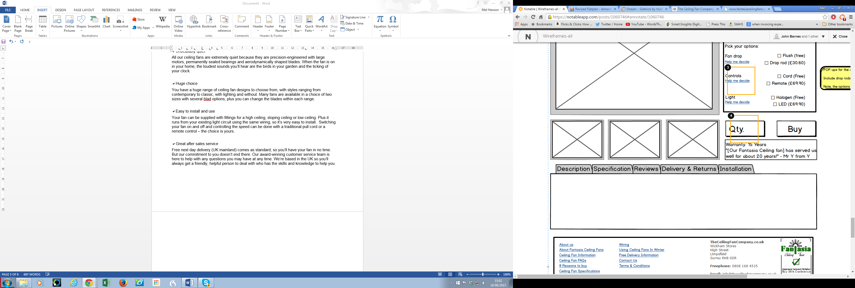

Delivery: As pop up above

**Installation**

Your fan comes with all the fixings required as well as an easy-to-follow installation guide.

Installing a fan is similar to installing a light fitting. Simply wire into your existing lighting circuit (two core and earth). Connect the coloured wires of the fan to the matching coloured wires of your household electricity supply, following the coloured diagrams supplied in your guide.

For peace of mind, many people prefer to have their ceiling fans installed by a qualified electrician. Should you decide to do this, then rest assured, it should be a simple and quick job for them to do.

For technical advice please call 01959 564440 or email [technical@fantasiaceilingfans.com](mailto:technical@fantasiaceilingfans.com).

NOTE: Your ceiling should be at least 7ft 6” (2.3m) from the floor and the tips of the fan need to be at least 8” (20cm) away from any objects such as a beam or sloping walls. Please check your ceiling is solidly constructed (eg: standard joists and plaster, not plasterboard) as the fixing point needs to be capable of supporting ten times the weight of the fan due to the thrust generated by the movement of the blades.

Everything you need to install the fan is included in the box. However, if you have a sloping ceiling you may need to purchase an additional mounting. If you have a very high ceiling you or a conservatory, you may need to purchase a drop rod and conversion kit.